H.T No
Regulations:
A17

Sreenidhi Institute of Science and Technology
(An Autonomous Institution)
Code No: 6X104 Date: 30-Jan-2019 (FN)

M.Tech I-Year I-Semester End External Examination, Jan/Feb-2019 (Regular/Supplementary)
COMPUTER METHODS IN POWER SYSTEMS (EPE)

Time: 3 Hours Max.Marks:75

Note: a) No additional answer sheets will be provided.
b) All sub-parts of a question must be answered at one place only, otherwise it will not be valued.
c) Missing data can be assumed suitably.

Part - A Max.Marks:25

Answer all QUESTIONS.

1. | What are the advantages of per unit system? | [3M]
2. | In a graph if there are 4 nodes and 7 elements, then what is the number of links? | [3M]
3. | Which is the best method for accurate load flow calculations on a large power system? | [3M]
4. | A synchronous machine having E=1.2pu is supplying power to an infinite bus with voltage 1.0pu. If the transfer reactance is 0.6pu, find the steady state power limit. | [3M]
5. | Why transient stability limit is lower than steady state stability limit. | [3M]
6. | A control area has a total rated capacity of 10000MW and regulation ‘R’ for all the UNITs in the area is 2Hz /Pu Mw .One percent change in frequency causes one percent change in loop. If the system is operating at half the rated capacity and the load increased by 20%.Find static frequency drop | [2M]
7. | What are the advantages of Y_{bus} matrix over Z_{Bus} Matrix? | [2M]
8. | Which quantities are specified at voltage controlled bus? | [2M]
9. | Define Transfer reactance. | [2M]
10. | Write the objective of finding fault levels at bus. | [2M]
Part – B Max.Marks:50
ANSWER ANY FIVE QUESTIONS. EACH QUESTION CARRIES 10 MARKS.

11. | a) | For the power system network shown in figure use ground as a reference Bus. Define a tree and co-tree. Write the Bus-Branch incidence matrix and use it to obtain Y_{BUS}? Select arbitrary directions.  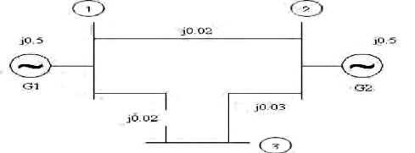 | [5M]
 | b) | Find the Y_{BUS} by direct inspection method for the network shown below:  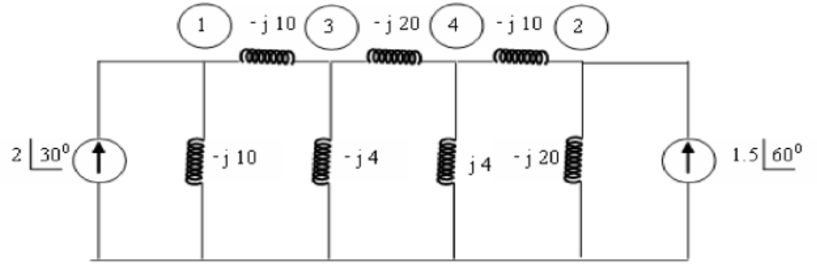 | [5M]
12. | a) | Derive the equations for total fault current in terms of symmetrical components for the three phase (not grounded) fault at bus P. | [5M]
 | b) | Derive the analytical expression for currents and voltages of three-phase to ground fault. | [5M]
13. | a) | Explain the necessity of load flow solution. | [3M]
 | b) | Write an algorithm for Newton Raphson load flow method by considering all types of buses. | [7M]
14. |  | Explain about the Euler modified method? | [10M]
15. | a) | Explain what is “swing Curve”? Explain its practical significance in stability analysis. | [5M]
 | b) | Define transient stability and what are the methods of improving it? | [5M]
16. | a) | Explain the load frequency control of two area  i) uncontrolled case ii) controlled case. | [5M]
 | b) | Explain the steady state analysis of when for a single area system. | [5M]
17. | a) | Define the following terms :  i. Steady state stability limit.  ii. Dynamic state stability limit.  iii. Transient state stability limit. | [5M]
 | b) | List the assumptions made in the transient stability solution techniques. | [5M]

-- 00 -- 00 –

